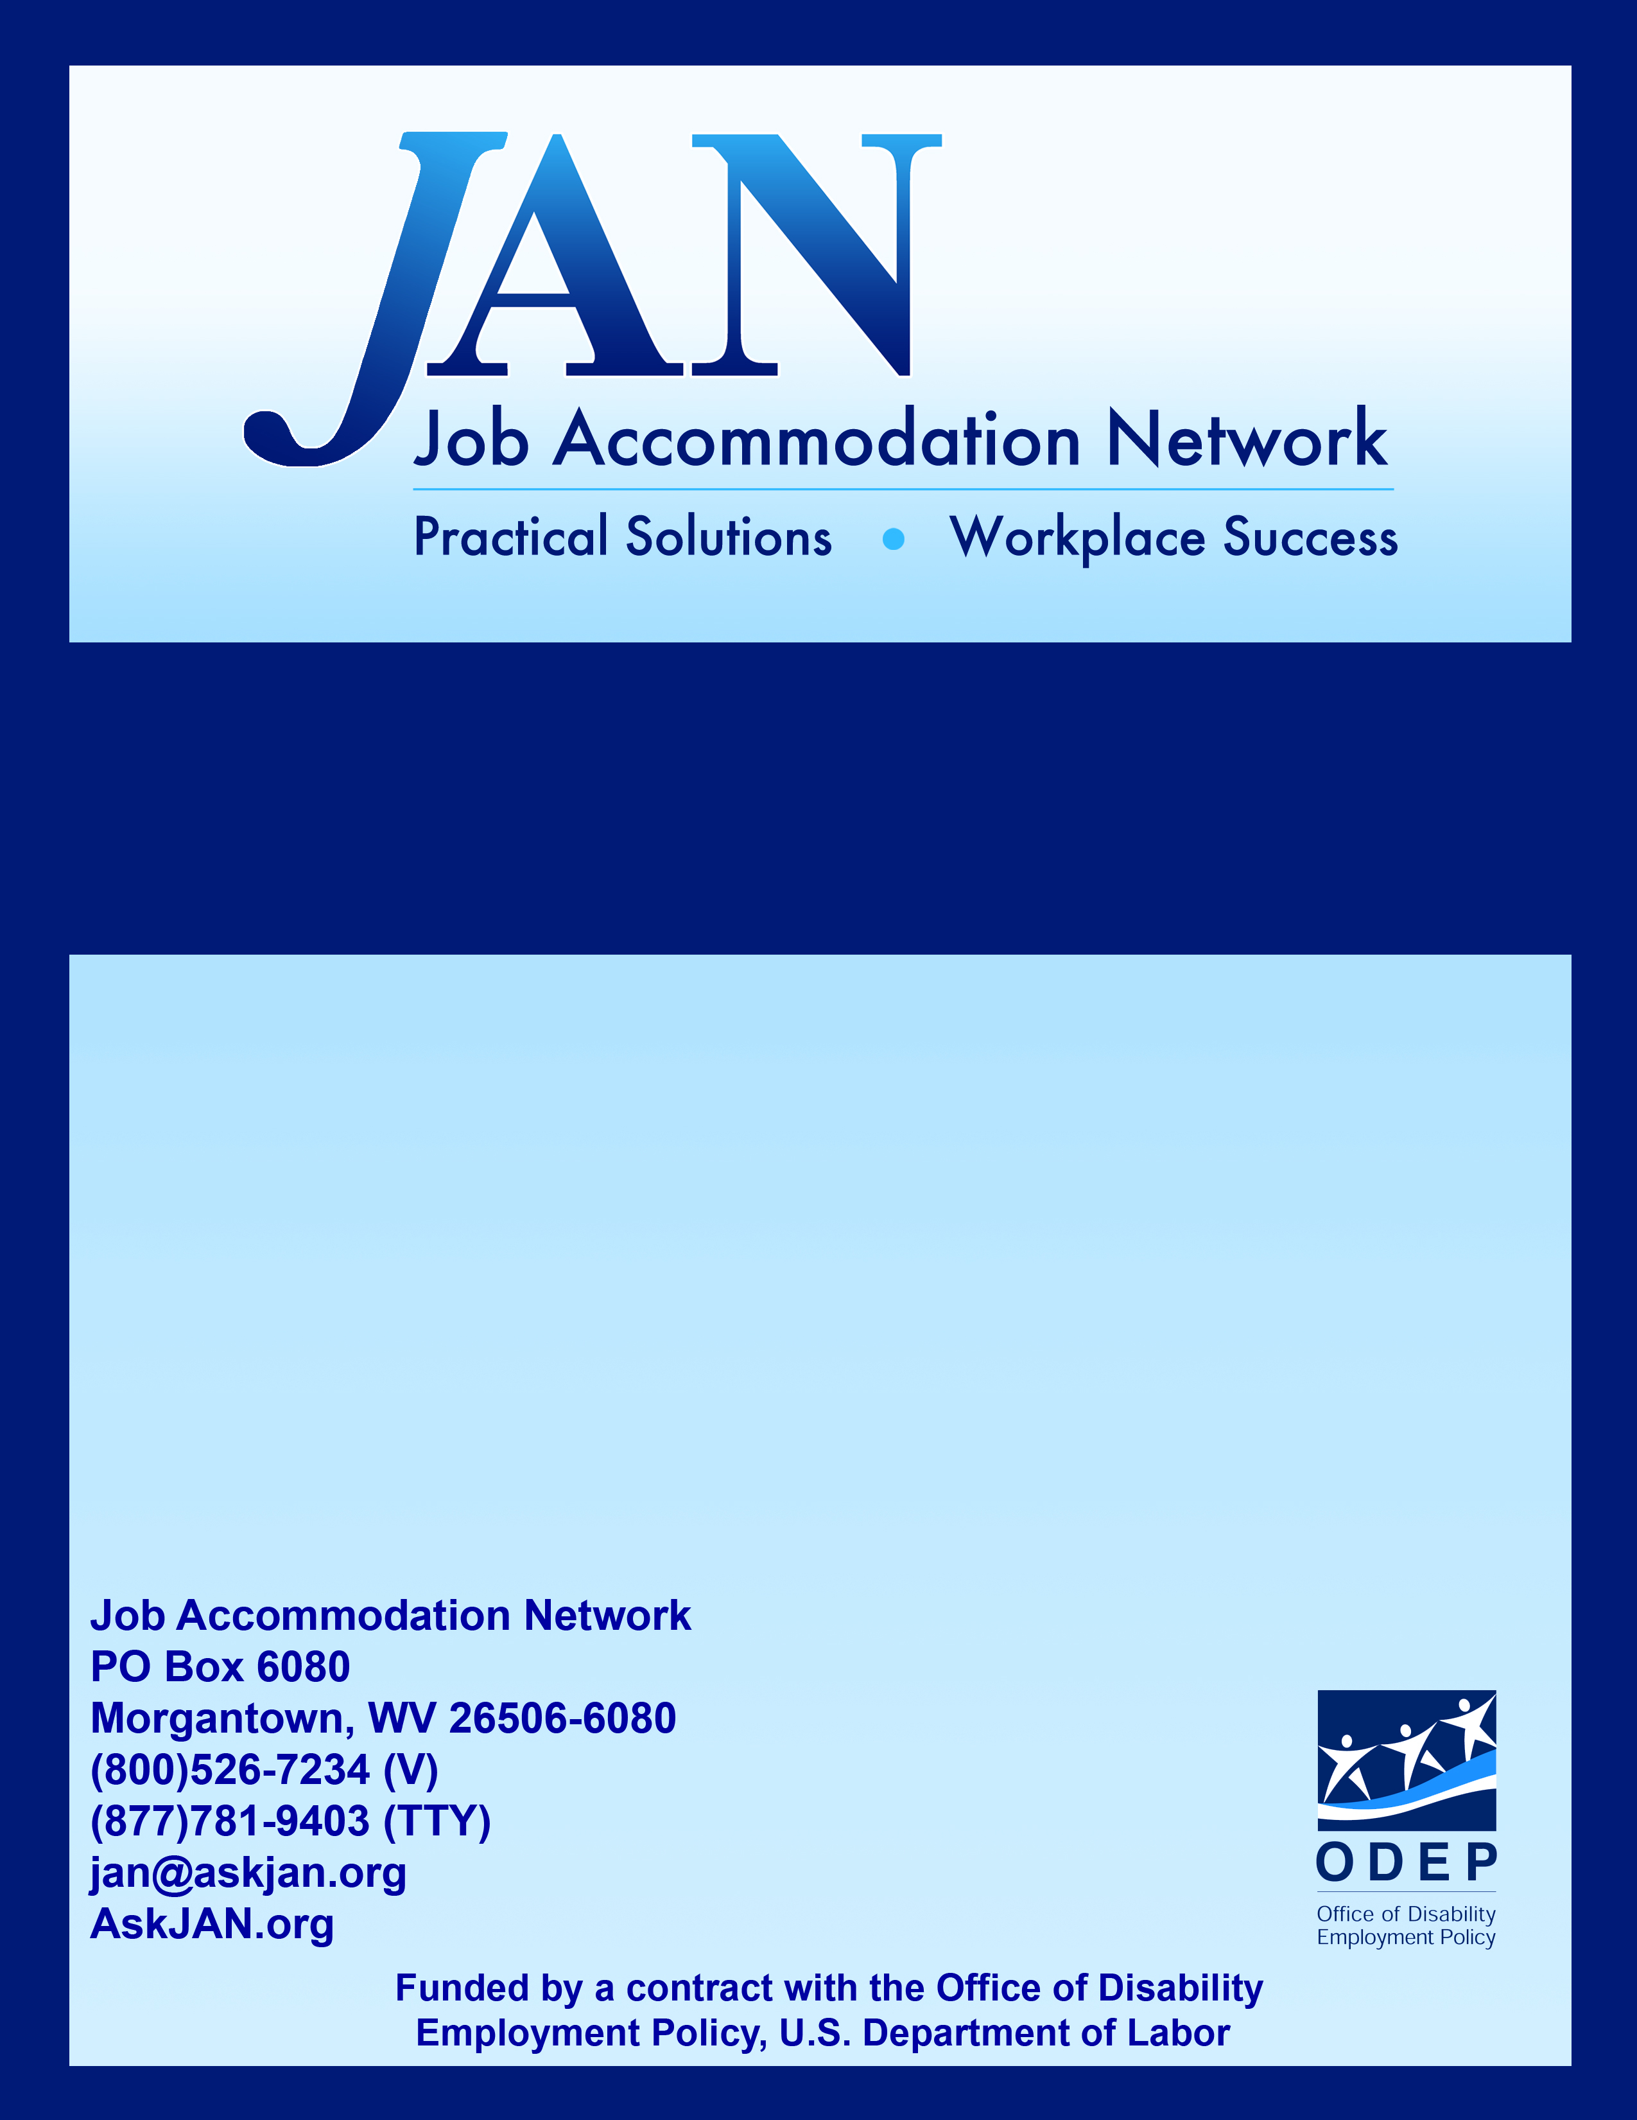
Disability Etiquette Tips for Speaking Engagements

Effective Accommodation Practices (EAP) Series

Disability Etiquette Tips for Speaking Engagements
- When talking to a person with a disability, look at and speak directly to that person, rather than through a companion or attendant.
- When referring to a person with a disability, make reference to the person first, then the disability. Use terminology such as "a person with a disability" rather than a "disabled person."
- To accommodate individuals with learning disabilities and vision impairments when using presentation slides, be sure to explain what is on the slide. Highlight points and convey enough information to describe pictures to someone who has no vision. Also provide information in several types of alternative formats (tapes, Braille, diskette). Watch for inadequate lighting, which inhibits communication by persons who have hearing and learning limitations.
- Do not touch a service animal, or the person the animal assists, without permission. Noises may distract the animal from doing his/her job, and feeding the service animal may disrupt the animal's schedule.
- Listen attentively when talking with a person who has a speech impairment. Keep your manner encouraging rather than correcting. Exercising patience rather than attempting to speak for a person may be helpful. When necessary, ask short questions that require short answers or a nod or a shake of the head. Never pretend to understand if you are having difficulty doing so.
- To get the attention of a person with a hearing impairment, tap the person on the shoulder or wave your hand. Look directly at the person and speak clearly, naturally, and slowly to establish if the person can read lips. Not all individuals with hearing impairments can lip-read. Those who can will rely on facial expressions and other body language to help in understanding. Show consideration by placing yourself facing the light source and keeping your hands away from your mouth when speaking. Shouting probably will not help but written notes may. To facilitate conversation, be prepared to offer a visual cue to a hearing impaired person or an audible cue to a vision impaired person, especially when more than one person is speaking.
- When talking with a person who uses a wheelchair or scooter for more than a few minutes, use a chair whenever possible in order to place yourself at the person's eye level; this facilitates conversation. Do not move a wheelchair, crutches, or other mobility aid out of reach of a person who uses them. Also, do not push a mobility aid without first asking the occupant if you may do so, lean on a person's mobility aid when talking, or pat a person who uses a wheelchair or scooter on the head. Make sure that audiovisual equipment does not block the view of people who use accessible seating; clearing the aisles of excess debris for the use of mobility aids may be useful. Be alert to the possible existence of architectural barriers.

This publication was prepared by Beth Loy, Ph.D. Updated 05/31/2018.

This document was developed by the Job Accommodation Network, funded by a contract from the U.S. Department of Labor, Office of Disability Employment Policy (#1605DC-17-C-0038). The opinions expressed herein do not necessarily reflect the position or policy of the U.S. Department of Labor. Nor does mention of tradenames, commercial products, or organizations imply endorsement by the U.S. Department of Labor.

